Coordinated Science Term 2 Test Support

1. Question

What are climate change feedback loops?

The more ice that melts, the more dark-coloured ocean is exposed, and the more heat the world absorbs. Photograph: Nick Cobbing/Greenpeace/Reuters

In climate change, a feedback loop is the equivalent of a vicious or virtuous circle – something that accelerates or decelerates a warming trend. A positive feedback accelerates a temperature rise, whereas a negative feedback decelerates it.

Scientists are aware of a number of positive feedbacks loops in the climate system. One example is melting ice. Because ice is light-coloured and reflective, a large proportion of the sunlight that hits it is bounced back to space, which limits the amount of warming it causes. But as the world gets hotter, ice melts, revealing the darker-coloured land or water below. The result is that more of the sun's energy is absorbed, leading to more warming, which in turn leads to more ice melting – and so on.

Various other feedbacks – related to emissions from soils and permafrost, for example, and changes to ocean evaporation – are known or thought to exist.

Feedback loops such as these are complex in themselves and even more complex when considered as part of an integrated global climate system. Some are already at work, while others have yet to kick in. Others still – both positive and negative – may yet be discovered. These uncertainties, coupled with historical evidence for the climate changing rapidly in the past, led one prominent climate scientist to compare releasing greenhouse gases into the air with "poking a beast with a sharp stick".

1. Question

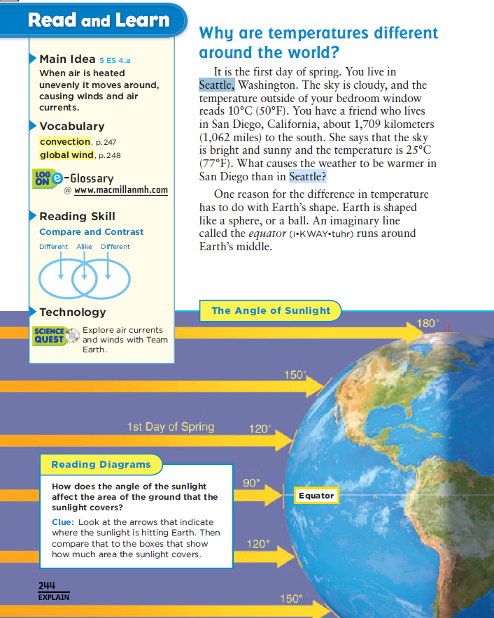

3) Question

Why Do We have Seasons?

As the earth spins on its axis, producing night and day, it also moves about the sun in an elliptical (elongated circle) orbit that requires about 365 1/4 days to complete. The earth's spin axis is tilted with respect to its orbital plane. This is what causes the seasons. When the earth's axis points towards the sun, it is summer for that hemisphere. When the earth's axis points away, winter can be expected. Since the tilt of the axis is 23 1/2 degrees, the North Pole never points directly at the Sun, but on the summer solstice it points as close as it can, and on the winter solstice as far as it can. Midway between these two times, in spring and autumn, the spin axis of the earth points 90 degrees away from the sun. This means that on this date, day and night have about the same length: 12 hours each, more or less.

Why should this tilt of the Earth's axis matter to our weather? To understand this, take a piece of paper and a flashlight. Shine the light from the flashlight straight onto the paper, so you see an illuminated circle. All the light from the flashlight is in that circle. Now slowly tilt the paper, so the circle elongates into an ellipse. All the light is still in that ellipse, but the ellipse is spread out over more paper. The density of light drops. In other words, the amount of light per square centimeter drops (the number of square centimeters increases, while the total amount of light stays the same).

The same is true on the earth. When the sun is overhead, the light is falling straight on you, and so more light (and more heat) hit each square centimeter of the ground. When the sun is lower in the sky, the light gets more spread out over the surface of the earth, and less heat (per square centimeter) can be absorbed. Since the earth's axis is tilted, the sun is higher when you are on the part of the earth where the axis points more towards the sun, and lower on the part of the Earth where the axis points away from the sun.

For the Northern Hemisphere, the axis points most toward the sun in June (specifically around June 21), and away from the sun around December 21. This corresponds to the Winter and Summer Solstice (solstice is Latin for "the sun stands"). For the Southern Hemisphere, this is reversed.

For both hemispheres, the earth is 90 degrees away from the sun around March 21 and then again around September 21. This corresponds to the Fall and Spring Equinox (equinox is Latin for "equal night"). Everyplace in the world has about 12 hours of daylight and 12 hours of night.

4) Question This is an example of:

## Positive and negative feedback in glacial periods

Each glacial period is subject to [positive feedback](https://en.wikipedia.org/wiki/Positive_feedback) which makes it more severe, and [negative feedback](https://en.wikipedia.org/wiki/Negative_feedback) which mitigates and (in all cases so far) eventually ends it.

### Positive feedback processes

Ice and snow increase Earth's [albedo](https://en.wikipedia.org/wiki/Albedo), i.e. they make it reflect more of the sun's energy and absorb less. Hence, when the air temperature decreases, ice and snow fields grow, and this continues until competition with a negative feedback mechanism forces the system to an equilibrium. Also, the reduction in [forests](https://en.wikipedia.org/wiki/Boreal_forest) caused by the ice's expansion increases albedo.

5. Question

Energy and Latitude Different parts of Earth’s surface receive different amounts of sunlight (Figure below). The Sun’s rays strike Earth’s surface most directly at the Equator. This focuses the rays on a small area. Near the poles, the Sun’s rays strike the surface at a slant. This spreads the rays over a wide area. The more focused the rays are, the more energy an area receives, and the war

**Energy Difference between the Equator and the Poles**

|  |  |  |
| --- | --- | --- |
| https://sealevel.jpl.nasa.gov/layout/ostm/images/spacer.gif | The orientation of the Earth's poles relative to the Sun causes the difference in energy received at the Equator and the poles.  Energy Difference between the Equator and the Poles  The average amount of incoming solar radiation decreases from the Equator to the poles. This is because the low latitudes (near the Equator) receive relatively large amounts of radiation all year, AND at high latitudes (near the poles), the more oblique angle of the Sun's rays together with long periods of darkness in the winter, result in a low average amount of received radiation.  6. Question  For millennia, Earth’s climate has hinged on the behavior of ice: the cycle of glacier growth and retreat. These alternating glacial and [interglacial periods](https://eos.org/research-spotlights/characterizing-interglacial-periods-over-the-past-800000-years) coincide with variations in Earth’s orbit called [Milankovitch cycles](http://earthobservatory.nasa.gov/Features/Milankovitch/milankovitch_2.php), which affect the insolation, or sunlight exposure, of different regions and thus the behavior of [ice formation](https://eos.org/articles/scientists-find-the-point-of-no-return-for-antarctic-ice-cap).  The average length of glacial periods has changed over time, from cycles of roughly 40,000 years that were more closely aligned to changes in obliquity—the tilt of Earth’s axis—to cycles of roughly 100,000 years, coinciding with [changes in the eccentricity](https://eos.org/research-spotlights/earths-climate-cycles-might-have-an-eccentric-explanation), or shape, of our planet’s orbit. The transition between 40,000- and 100,000-year cycles last occurred in the mid-Pleistocene. However, scientists have struggled to identify exactly how ice ages start, why they line up with these cycles, and why the lengths of and gaps between glacial periods vary through time.  Milankovitch Cycles  What are Milankovitch Cycles? Natural global warming, and cooling, is considered to be initiated by Milankovitch cycles. These orbital and axial variations influence the initiation of climate change in long-term natural cycles of 'ice ages' and 'warm periods' known as 'glacial' and 'interglacial' periods. Our current climate forcing shows we are outside of that natural cycle forcing range.  Milankovitch Cycles  Where are we currently in the natural Milankovitch cycle?  Pre-industrial forcing estimated around 0.0 to -0.1W/m2  The natural cycle that people refer to regarding large scale climate change is the time between ice ages and warm periods. The long cycle time is about 100,000 years. We can spend around 20% of the cycle in an interglacial and around 80% in an ice age, depending on where we are in these cycle influences.  What causes this are the natural cycles that influence earth climate – the Milankovitch Cycles?  The Milankovich cycles are caused by changes in the shape of the Earth's orbit around the sun, the tilt of the Earth's rotation axis, and the wobble of our axis. The mass and movement of the other planets in our solar system actually affect the Earth orbit just as our planetary mass similarly affects their orbits.  As the Earth's orbit changes, so too does the amount of sunlight that falls on different latitudes and in seasons. The amount of sunlight received in the summer at high northern latitudes appears to be especially important to determining whether the Earth is in an ice age or not. When the northern summer sun is strong, the Earth tends to be in a warm period. When it is weak we tend to be in an ice age. As we come out of an ice age, the sea level rises about 400 feet, and we enjoy a warm period 'like' the one we are in now. That is the natural cycle, brief warm periods followed by an ice age about every 100 thousand years.  7. Question  One way that the world’s ocean affects weather and climate is by playing an important role in keeping our planet warm. The majority of radiation from the sun is absorbed by the ocean, particularly in tropical waters around the equator, where the ocean acts like a massive, heat-retaining solar panel. Land areas also absorb some sunlight, and the atmosphere helps to retain heat that would otherwise quickly radiate into space after sunset.  The ocean doesn't just store solar radiation; it also helps to distribute heat around the globe. When water molecules are heated, they exchange freely with the air in a process called evaporation. Ocean water is constantly evaporating, increasing the temperature and humidity of the surrounding air to form rain and storms that are then carried by trade winds. In fact, almost all rain that falls on land starts off in the ocean. The tropics are particularly rainy because heat absorption, and thus ocean evaporation, is highest in this area.  Outside of Earth’s equatorial areas, weather patterns are driven largely by [ocean currents](https://oceanexplorer.noaa.gov/facts/currents.html). Currents are movements of ocean water in a continuous flow, created largely by surface winds but also partly by temperature and salinity gradients, Earth’s rotation, and tides. Major current systems typically flow clockwise in the northern hemisphere and counterclockwise in the southern hemisphere, in circular patterns that often trace the coastlines.  Ocean currents act much like a conveyor belt, transporting warm water and precipitation from the equator toward the poles and cold water from the poles back to the tropics. Thus, ocean currents regulate global climate, helping to counteract the uneven distribution of solar radiation reaching Earth’s surface. Without currents in the ocean, regional temperatures would be more extreme—super hot at the equator and frigid toward the poles—and much less of Earth’s land would be habitable.  8. Question  **In order, the most abundant greenhouse gases in Earth's atmosphere are:**   * Water vapor (H. 2O) * Carbon dioxide (CO. ... * Methane (CH. ... * Nitrous oxide (N. 2O) * Ozone (O. ... * Chlorofluorocarbons (CFCs) * Hydrofluorocarbons (includes HCFCs and HFCs)   **Oxygen** and nitrogen are **not greenhouse gases**, because they are transparent to infrared light. These molecules are invisible because when you stretch one, it doesn't change the electric field. These are symmetric molecules, made of two identical atoms whose electric fields just cancel each other out  9) Question  I Temperature Change and Carbon Dioxide Change  One of the most remarkable aspects of the paleoclimate record is the strong correspondence between temperature and the concentration of carbon dioxide in the atmosphere observed during the glacial cycles of the past several hundred thousand years. When the carbon dioxide concentration goes up, temperature goes up. When the carbon dioxide concentration goes down, temperature goes down. A small part of the correspondence is due to the relationship between temperature and the solubility of carbon dioxide in the surface ocean, but the majority of the correspondence is consistent with a feedback between carbon dioxide and climate. These changes are expected if Earth is in radiative balance, and they are consistent with the role of greenhouse gases in climate change. While it might seem simple to determine cause and effect between carbon dioxide and climate from which change occurs first, or from some other means, the determination of cause and effect remains exceedingly difficult. Furthermore, other changes are involved in the glacial climate, including altered vegetation, land surface characteristics, and ice sheet extent.  [A study by GISS climate scientists](http://www.giss.nasa.gov/research/briefs/lacis_01/) recently published in the journal Science shows that **atmospheric CO2 operates as a thermostat to control the temperature of Earth**….  CO2 is the key atmospheric gas that exerts principal control (80% of the non-condensing GHG forcing) over the strength of the terrestrial greenhouse effect. Water vapor and clouds are fast-acting feedback effects, and as such, they are controlled by the radiative forcing supplied by the non-condensing GHGs….  There is no viable alternative to counteract global warming except through direct human effort to reduce the atmospheric CO2 level.  We begin with a very simplified review of what the greenhouse effect is. Solar radiation, mostly short-wave radiation, passes through the atmosphere and warms the surface. In turn, the heated surface re-radiates energy as long-wave infrared radiation back to the atmosphere and eventually, back to space.  Greenhouse gases in the atmosphere intercept some of the long-wave infrared radiation and transfer some of the energy to excite other molecules in the atmosphere, some of the radiation goes back to the surface (this is called down-welling infrared radiation), and some of the radiation is radiated into space (this is called out-going long-wave radiation).  The carbon dioxide concentration in the atmosphere has been increasing due in part to emissions from burning fossil fuels. This increased amount of CO2 should “intensify” the greenhouse effect and cause global warming according to the National Climate Assessment and the IPCC. So, what phenomena should we observe from an “intensified” greenhouse effect?  With an “intensified” greenhouse effect, we should see a decrease in out-going long-wave infrared radiation into space. We should see warming of the atmosphere (the troposphere), a “hot spot” especially over the tropics. We should see more down-welling infrared radiation that further warms the surface. That’s the essence of the anthropogenic global warming (AGW) hypothesis. But, real-world measurements show we are seeing none of those effects.  10. Question  **The following is a list of 10 steps YOU can take to reduce greenhouse gas emissions:**   1. Reduce, Reuse, Recycle. ... 2. Use Less Heat and Air Conditioning. ... 3. Replace Your Light Bulbs. ... 4. Drive Less and Drive Smart. ... 5. Buy Energy-Efficient Products. ... 6. Use Less Hot Water. ... 7. Use the "Off" Switch. ... 8. Plant a Tree. 9. Question   What is the carbon cycle? Carbon is the chemical backbone of all life on Earth. All of the carbon we currently have on Earth is the same amount we have always had. When new life is formed, carbon forms key molecules like protein and DNA. It's also found in our atmosphere in the form of carbon dioxide or CO2. The carbon cycle is nature's way of reusing carbon atoms, which travel from the atmosphere into organisms in the Earth and then back into the atmosphere over and over again. Most carbon is stored in rocks and sediments, while the rest is stored in the ocean, atmosphere, and living organisms. These are the reservoirs, or sinks, through which carbon cycles. The ocean is a giant carbon sink that absorbs carbon. Marine organisms from marsh plants to fish, from seaweed to birds, also produce carbon through living and dying. Sometimes dead organisms become fossil fuels that go through combustion, giving off CO2, and the cycle continues.  12. Question | https://sealevel.jpl.nasa.gov/layout/ostm/images/spacer.gif |

The sand should both heat and cool faster than the water. This is because water has a higher specific heat capacity than sand – meaning that it takes a lot of heat, or energy, to raise the temperature of water one degree, whereas it takes comparatively little energy to change the temperature of sand by one degree. The high specific heat capacity of water also explains why it cools slower. More heat must be removed from the water to lower the temperature by one degree than must be removed by the sand to lower its temperature by one degree. The materials also absorb different amounts of heat due to their colors, but the main factor at play is heat capacity, so changing the heating method should not change the qualitative results.

13/14

A mountain range in the path of prevailing winds can influence where precipitation falls. When humid winds blow from the ocean toward coastal mountains, they are forced to rise. The rising air cools and its water vapor condenses, forming clouds. Rain or snow falls on the windward side of the mountains, the side the wind hits. 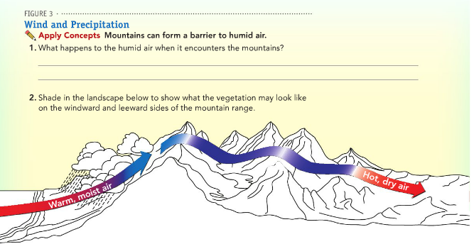

15) Question

**The Natural Greenhouse Effect**

Just as the major atmospheric gases (oxygen and nitrogen) are transparent to incoming sunlight, they are also transparent to outgoing thermal infrared. However, water vapor, carbon dioxide, methane, and other trace gases are opaque to many wavelengths of thermal infrared energy. Remember that the surface radiates the net equivalent of 17 percent of incoming solar energy as thermal infrared. However, the amount that directly escapes to space is only about 12 percent of incoming solar energy. The remaining fraction—a net 5-6 percent of incoming solar energy—is transferred to the atmosphere when greenhouse gas molecules absorb thermal infrared energy radiated by the surface.

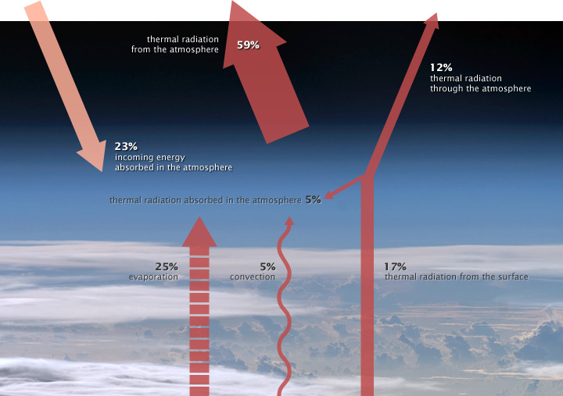

The atmosphere radiates the equivalent of 59% of incoming sunlight back to space as thermal infrared energy, or heat. Where does the atmosphere get its energy? The atmosphere directly absorbs about 23% of incoming sunlight, and the remaining energy is transferred from the Earth’s surface by evaporation (25%), convection (5%), and thermal infrared radiation (a net of 5-6%). The remaining thermal infrared energy from the surface (12%) passes through the atmosphere and escapes to space. (NASA illustration by Robert Simmon. Astronaut photograph [ISS017-E-13859.](http://eol.jsc.nasa.gov/scripts/sseop/photo.pl?mission=ISS017&roll=E&frame=13859))

When greenhouse gas molecules absorb thermal infrared energy, their temperature rises. Like coals from a fire that are warm but not glowing, greenhouse gases then radiate an increased amount of thermal infrared energy in all directions. Heat radiated upward continues to encounter greenhouse gas molecules; those molecules absorb the heat, their temperature rises, and the amount of heat they radiate increases. At an altitude of roughly 5-6 kilometers, the concentration of greenhouse gases in the overlying atmosphere is so small that heat can radiate freely to space.

Because greenhouse gas molecules radiate heat in all directions, some of it spreads downward and ultimately comes back into contact with the Earth’s surface, where it is absorbed. The temperature of the surface becomes warmer than it would be if it were heated only by direct solar heating. This supplemental heating of the Earth’s surface by the atmosphere is the natural greenhouse effect.

16. Question

Ice sheets have one particularly special property. They allow us to go back in time and to sample accumulation, air temperature and air chemistry from another time[1]. Ice core records allow us to generate continuous reconstructions of past climate, going back at least 800,000 years[2]. By looking at past concentrations of greenhouse gasses in layers in ice cores, scientists can calculate how modern amounts of carbon dioxide and methane compare to those of the past, and, essentially, compare past concentrations of greenhouse gasses to temperature.

Ice coring has been around since the 1950s. Ice cores have been drilled in ice sheets worldwide, but notably in Greenland[3] and Antarctica[4, 5]. High rates of snow accumulation provide excellent time resolution, and bubbles in the ice core preserve actual samples of the world’s ancient atmosphere[6]. Through analysis of ice cores, scientists learn about glacial-interglacial cycles, changing atmospheric carbon dioxide levels, and climate stability over the last 10,000 years. Many ice cores have been drilled in Antarctica.

17. Question

-Green plants remove carbon dioxide from the atmosphere by photosynthesis. Living organisms - including all plants and animals - release energy from their food using respiration. Respiration and combustion - burning - both release carbon dioxide into the atmosphere. -Green plants remove carbon dioxide from the atmosphere by photosynthesis. Living organisms - including all plants and animals - release energy from their food using respiration. Respiration and combustion - burning - both release carbon dioxide into the atmosphere.

18. Question

What is an ice age? An ice age is a period in Earth's history when the ice on the polar caps significantly expands due to a lowering of the Earth's global temperatures. Over the course of millions of years, scientists believe that the Earth has experienced at least five major ice ages. During these periods land in North America and Northern Europe were covered by giant ice sheets and glaciers. Earth is currently in an ice age called the Quaternary Ice Age which began around 2.5 million years ago and is still going on. We are currently in an interglacial stage of this ice age. The periods within ice ages are defined as: Glacial- A glacial period is a cold period when the glaciers are expanding. Interglacial- A warming period when the glaciers and ice sheets are receding.

What causes an ice age? The Earth is constantly undergoing changes. These changes can impact the global climate. Some of the changes that can influence an ice age include: Earth's orbit - Changes in the Earth's orbit (called Milankovitch cycles) can cause the Earth to be closer to the Sun (warmer) or further from the Sun(colder). Ice ages can occur when we are further from the Sun. Solar energy - The amount of energy output by the Sun also changes. Low cycles of energy output can possibly help in producing an ice age. Atmospheric composition - Low levels of greenhouse gasses such as carbon dioxide can cause the Earth to cool leading to an ice age. Ocean currents-can have a great impact on the Earth's climate. Changes in currents can cause ice sheets to build up. Volcanoes - introduce huge amounts of carbon dioxide into the atmosphere. The lack of volcanoes can cause an ice age. Increased volcanic activity can put an end to an ice age as well.

19. Question

Paleoclimatology is the study of climatic conditions, and their causes and effects, in the geologic past, using evidence found in glacial deposits, fossils, and sediments.

The average temperature of the Earth is variable on all time scales. Millions of years ago, dinosaurs lived near the South Pole during a particularly warm era. Thick ice sheets covered large areas of the earth only 20,000 years ago.

The thick ice that covers Antarctica preserves a continuous record of the Earth's climate during the past 400,000 years. The record is a treasure trove of information about how climate works. Look at how carbon dioxide, methane and temperature have varied.**[1, 2]** There have been 4 cycles during the past 400,000 years. Each cycle starts with a sudden warming followed by a long and irregular cooling period. The warm periods between glaciations typically last only about 1000 years. The warm period we live in is unique. It has lasted an unusual 10,000 years and the temperature has been very steady compared to other eras.

20. Question

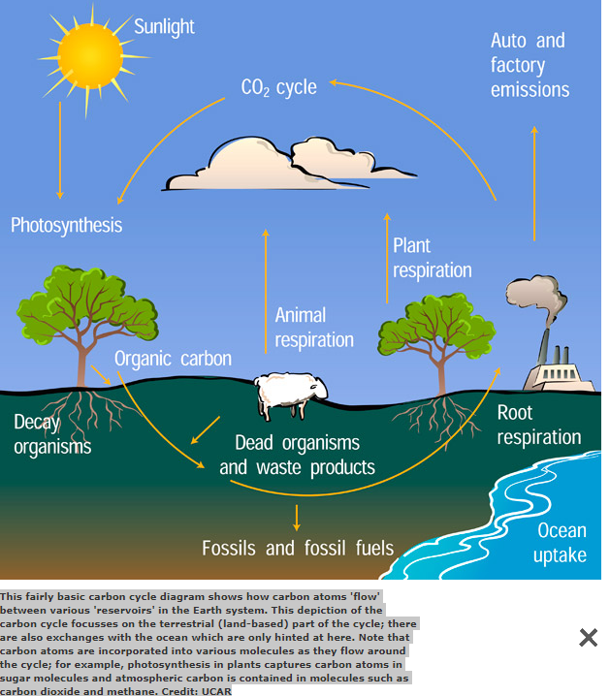

Carbon moves from living things to the atmosphere. Each time you exhale, you are releasing carbon dioxide gas (CO2) into the atmosphere. Animals and plants need to get rid of carbon dioxide gas through a process called respiration. The burning of fossil and fossil fuels release carbon dioxide into the air.

21. Question

When pollen grains are washed or blown into bodies of water, their tough outer walls allow them to be preserved in sediment layers in the bottoms of ponds, lakes, or oceans. Because of their unique shapes, scientists can then take a core sample of the sediment layers and determine what kinds of plants were growing at the time the sediment was deposited. Knowing what types of plants were growing in the area allows the scientists to make inferences about the climate at that time by using knowledge about modern and historical distributions of plants in relation to climate.

Geologists can deduce much about a lake’s history and the history of the lake basin and climate from the sedimentary records on its bottom. A sediment core contains such clues as ripple marks caused by current or [wave](https://www.britannica.com/science/wave-water) action, carbonaceous layers, and alternations of strata that include cold- and warm-water species of fossils, pollen, and traces of chemicals of human derivation. These data provide the basis for extensive documentation of lake history (paleolimnology). Some well-known historical events, such as major volcanic eruptions, the clearing of North American forests by early settlers as revealed by pollen concentrations, the first extensive use of certain heavy metals by [industry](https://www.britannica.com/technology/industry), and nuclear explosions, provide reference points in the sediment record.

22. Question

Pollen grains are well preserved in the sediment layers because they are highly resistant to decay. The grains are very distinctive in shape and form and enable scientists to determine the types of plant life that grew in a certain period. Plants thrive off different climates and air conditions, so by determining what type of plants were present, will determine the climate condition of that period. Through the pollen grain samples, we were able to determine that pollen samples are good indicators of climate change. Plant pollen grains are very distinct in shape and form. This allowed us to determine what plant life inhabited the region during a specific period. Plants thrive off different climates and air conditions, so by determining what types of plants were present, we were able to determine the climate condition of that period. An analysis of the pollen grains produced from the soil samples indicated that climate change occurred in a cold to warm temperature pattern. This clearly suggests that there is a warming trend in the region. Also it was determined that certain plant species are not able to adapt in certain climates. Some plant species thrive in cold temperatures while others in warm temperatures.

23. Question

#### Parts of a Hydroelectric Plant

Most conventional hydroelectric plants include four major components (see graphic below):

1. **Dam.** Raises the water level of the river to create falling water. Also controls the flow of water. The reservoir that is formed is, in effect, stored energy.
2. **Turbine.** The force of falling water pushing against the turbine's blades causes the turbine to spin. A water turbine is much like a windmill, except the energy is provided by falling water instead of wind. The turbine converts the kinetic energy of falling water into mechanical energy.
3. [**Generator**](http://www.wvic.com/content.cfm?PageID=688&Cat=0)**.** Connected to the turbine by shafts and possibly gears so when the turbine spins it causes the generator to spin also. Converts the mechanical energy from the turbine into electric energy. Generators in hydropower plants work just like the generators in other types of power plants.
4. **Transmission lines**. Conduct electricity from the hydropower plant to homes and business.



Gravitational potential energy. A rock on top of a hill contains potential energy because of its position. If a force pushes the rock, it rolls down the hill because of the force of gravity. The potential energy is converted into kinetic energy until it reaches the bottom of the hill and stops. The water in a reservoir behind a hydropower dam is another example of potential energy. The stored energy in the reservoir is converted into kinetic energy (motion) as the water flows down a large pipe called a penstock and spins a turbine. The turbine spins a shaft inside the generator, where magnets and coils of wire convert the motion energy into electrical energy through a phenomenon called electromagnetism. This electricity is transmitted over power lines to consumers who use it to perform many tasks.

24. Question

### How does coal make electricity?

Simply put, coal-fired electricity generation is a five-step process:

1. Thermal coal (either black or brown) that has been pulverised to a fine powder is burned
2. The resulting heat is used to turn water into steam
3. The steam at very high pressure is then used to spin a turbine, connected to an electrical generator
4. The spinning turbine causes large magnets to turn within copper wire coils; this is called the generator
5. The moving magnets cause electrons in the wires to move from one place to another, creating an electrical current and producing electricity.

A coal-fired power plant involves these energy transformations: Chemical energy in the coal is converted into thermal energy in the exhaust gases of combustion. Thermal energy of the exhaust gases converted into thermal energy of steam through heat exchange

25. Question

Washington has some of the most affordable electricity in the country, in large part because hydroelectric power accounts for over two thirds of its electricity production. Washington is the leading hydroelectricity producing state in the nation.

Most of Washington’s hydroelectric power is generated from eight of the state’s ten largest power plants on the Columbia and Snake Rivers, natural resources that have enabled the state to keep electricity prices among the lowest in the nation. Washington is a major electricity exporter, supplying electricity to several other states, including California. Natural gas, coal, and nuclear combined generate almost 25 percent of the state’s electricity. Non-hydroelectric renewables, primarily wind, wood and wood waste, combined contributes almost 5 percent.

26. Question

## Electricity in the United States is produced with diverse energy sources and technologies

The United States uses many different energy sources and technologies to generate electricity. The sources and technologies have changed over time and some are used more than others.

The three major categories of energy for electricity generation are fossil fuels (coal, natural gas, and petroleum), nuclear energy, and renewable energy sources. Most electricity is generated with [steam turbines](https://www.eia.gov/tools/glossary/index.php?id=Steam%20turbine) using fossil fuels, nuclear, biomass, geothermal, and solar thermal energy. Other major electricity generation technologies include [gas turbines](https://www.eia.gov/tools/glossary/index.php?id=Gas%20turbine%20plant), hydro turbines, wind turbines, and solar photovoltaics.

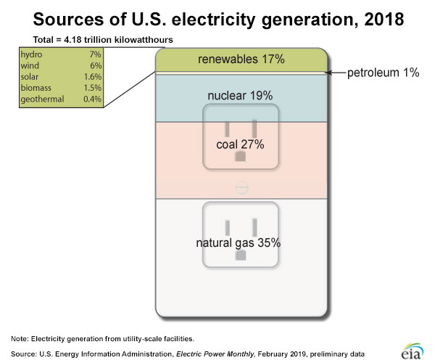

### Fossil fuels are the largest sources of energy for electricity generation

[Natural gas](https://www.eia.gov/energyexplained/natural-gas/) was the largest source—about 35%—of U.S. electricity generation in 2018. Natural gas is used in steam turbines and gas turbines to generate electricity.

[Coal](https://www.eia.gov/energyexplained/coal/) was the second-largest energy source for U.S. electricity generation in 2018—about 27%. Nearly all coal-fired power plants use steam turbines. A few coal-fired power plants convert coal to a gas for use in a gas turbine to generate electricity.

[Petroleum](https://www.eia.gov/energyexplained/oil-and-petroleum-products/) was the source of less than 1% of U.S. electricity generation in 2018. [Residual fuel oil](https://www.eia.gov/tools/glossary/index.php?id=Residual%20fuel%20oil) and [petroleum coke](https://www.eia.gov/tools/glossary/index.php?id=Coke%20%28petroleum%29) are used in steam turbines. [Distillate—or diesel—fuel oil](https://www.eia.gov/tools/glossary/index.php?id=Distillate%20fuel%20oil) is used in [diesel-engine generators](https://www.eia.gov/tools/glossary/index.php?id=Diesel%20fuel%20system). Residual fuel oil and distillates can also be burned in gas turbines.

27. Question

In physical sciences, **mechanical energy** is the sum of **potential energy** and **kinetic energy**. .... A **generator** converts **mechanical energy** into **electrical energy**.

28. Question

An **electric motor** is an **electrical** machine that converts **electrical energy** into mechanical **energy**. Most **electric motors** operate through the interaction between the **motor's** magnetic field and **electric** current in a wire winding to generate force in the form of rotation of a shaft.

29. Question

|  |  |  |  |
| --- | --- | --- | --- |
| **What is Current?** An electrical phenomenon is caused by flow of free electrons from one atom to another. The characteristics of **current electricity** are opposite to those of static electricity.  Wires are made up of conductors such as copper or aluminum. Atoms of metal are made up of free electrons, which freely move from one atom to the next. If an electron is added in wire, a free electron is attracted to a proton to be neutral. Forcing electrons out of their orbits can cause a lack of electrons. Electrons, which continuously move in wire, are called **Electric Current**. | |  | |
|  |  |  |  |

30. Question

**A Car on a Hill**  
  
We can compare potential and kinetic energy by considering a car on a hill. When the car is at the top of the hill it has the most potential energy. If it is sitting still, it has no kinetic energy. As the car begins to roll down the hill, it loses potential energy, but gains kinetic energy. The potential energy of the position of the car at the top of the hill is getting converted into kinetic energy.

**Gravitational Potential Energy**  
  
One type of potential energy comes from the Earth's gravity. This is called gravitational potential energy (GPE). Gravitational potential energy is the energy stored in an object based on its height and mass. To calculate the gravitational potential energy we use the following equation:

**GPE = mass * g * height  
GPE = m*g*h**

Where "g" is the standard acceleration of gravity which equals 9.8 m/s2. The height is determined based on the height the object could potentially fall. The height may be the distance above the ground or perhaps the lab table we are working on.  
  
Example problems:  
  
What is the potential energy of a 2 kg rock sitting at the top of a 10 meter high cliff?  
  
GPE = mass * g * height  
GPE = 2kg * 9.8 m/s2 * 10m  
GPE = 196 J  
  
**Potential Energy and Work**  
  
The potential energy is equal to the amount of work done to get an object into its position. For example, if you were to lift a book off the floor and place it on a table. The potential energy of the book on the table will equal the amount of work it took to move the book from the floor to the table.  
  
What happens to potential energy as the car goes down the hill?

As the **car** coasts **down the hill**, it **moves** faster and so it's kinetic **energy** increases and it's **potential energy** decreases. On the way back up the **hill**, the **car** converts kinetic **energy** to **potential energy**.

31. Question

**Gravitational potential energy** is the **energy** that an object has because of its height and is equal to the object's mass multiplied by its height multiplied by the **gravitational** constant (PE = mgh). **Gravitational potential energy** is greatest at the highest **point** of a roller coaster and **least** at the **lowest point**. As the **car** coasts **down the hill**, it **moves** faster and so it's kinetic **energy** increases and it's **potential energy** decreases. On the way back up the **hill**, the **car** converts kinetic **energy** to **potential energy**.

32. Question

As the **car** coasts **down the hill**, it **moves** faster and so it's kinetic **energy** increases and it's **potential energy** decreases. On the way back up the **hill**, the **car** converts kinetic **energy** to **potential energy**. In all physical processes taking place in closed systems, the amount of change in **kinetic energy** is equal to the amount of change in potential **energy**. **If** the **kinetic energy increases**, the potential **energy decreases**, and vice-versa. If the force were to be removed, the object would fall back down to the ground and the gravitational potential energy would be transferred to kinetic energy of the falling object. Our article on [conservation of energy](https://www.khanacademy.org/science/physics/work-and-energy/work-and-energy-tutorial/a/what-is-conservation-of-energy) includes some example problems that are solved through an understanding of how gravitational potential energy is converted to other forms.

33. Question

**Disadvantages of Solar Energy**

* Cost. The initial cost of purchasing a solar system is fairly high. ...
* Weather Dependent. Although solar energy can still be collected during cloudy and rainy days, the efficiency of the solar system drops. ...
* Solar Energy Storage Is Expensive. ...
* Uses a Lot of Space. ...

**Disadvantages of Wind Energy**

* The Wind Fluctuates. Wind energy has a similar drawback to solar energy in that it is not constant. ...
* Installation is Expensive. Although costs are reducing over time, wind turbines are still expensive. ...
* Wind Turbines Pose A Threat to Wildlife. ...
* Wind Turbines Create Noise Pollution. ...
* They Also Create Visual Pollution.

34. Which of the following is true about renewable resources?

A **renewable resource**is a [natural resource](https://en.wikipedia.org/wiki/Natural_resource) which will replenish to replace the portion [depleted](https://en.wikipedia.org/wiki/Resource_depletion) by usage and consumption, either through natural reproduction or other recurring processes in a finite amount of time in a human time scale. Renewable resources are a part of Earth's natural environment and the largest components of its [ecosphere](https://en.wikipedia.org/wiki/Ecosphere_(ecology)). A positive life cycle assessment is a key indicator of a resource's sustainability.

**What is renewable energy?**  
  
Renewable energy uses energy sources that are not "used up". For example, solar power from the sun is renewable as we won't "use up" all the sunlight from the sun. Examples of non-renewable energy sources include [fossil](https://www.ducksters.com/science/earth_science/fossils.php) fuels like coal and oil. Once we use or burn these resources, they are gone forever.  
  
**Why is renewable energy important?**  
  
Much of the world relies on non-renewable energy to heat their homes, power their electronic devices, and power their cars. Once these energy sources are used up, they will be gone forever. Developing technologies that can efficiently use renewable energy sources is critical to our future.  
  
**The Environment**  
  
Many renewable energy sources are also better for the environment than burning fossil fuels. They produce less pollution which will help protect the environment and provide us with cleaner air and water.

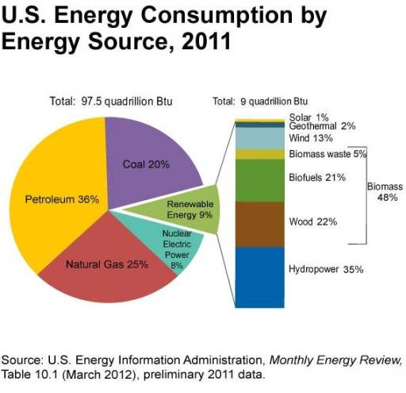

**Major Types of Renewable Energy**  
  
[Wind Power](https://www.ducksters.com/science/environment/wind_power.php) - Large wind turbines generate electricity from the power of the wind.  
  
[Solar Energy](https://www.ducksters.com/science/environment/solar_power.php) - The rays from the sun can help to heat a building or a pool. They can also be turned into electricity using solar cells.  
  
[Hydropower](https://www.ducksters.com/science/environment/hydropower.php) - Water from a dam or a river can be used to spin turbines and generate electricity.  
  
[Wave and Tidal Power](https://www.ducksters.com/science/environment/wave_and_tidal_energy.php) - This new technology is working on ways to harness the vast power of the ocean's waves and tides.  
  
[Geothermal Energy](https://www.ducksters.com/science/environment/geothermal_energy.php) - Heat from inside the Earth can be used to heat homes and buildings with heat pumps. Steam from inside the Earth can also be used to generate electricity.  
  
[Biomass Energy](https://www.ducksters.com/science/environment/biomass_energy.php) - Plants gather energy from the sun by photosynthesis. We can harness this energy by burning plants such as trees as well as creating fuel from plants such as ethanol and biodiesel. Even gas from trash and manure can be used to create energy.

35. Question

Most renewable **energy sources** are **carbon**-free. This means that they **do not** emit any **carbon dioxide** when they generate **energy**. Solar, wind, and hydroelectric are **carbon**-free. Nuclear, though **not** renewable, is also considered a **carbon**-free **energy source**, because unlike coal and natural gas, it **does not** burn.

Does biomass produce carbon dioxide?

Burning either fossil fuels or **biomass** releases **carbon dioxide** (**CO2**), a greenhouse gas. However, the plants that are the source of **biomass** capture a nearly equivalent amount of **CO2** through photosynthesis while they are growing, which **can** make **biomass** a **carbon**-neutral energy source.

36. Question

Most fossil fuels, such as oil, natural gas, and **coal** are considered **nonrenewable resources**, as their use is **not** sustainable because their formation takes billions of years. ... **Examples** of **renewable resources** include solar power, wind power, timber, and water.